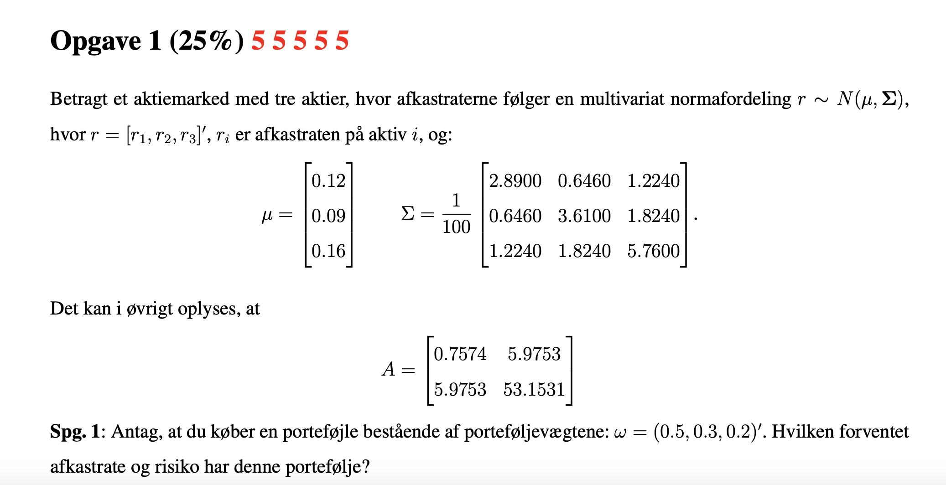
$$μ=\left(\begin{aligned}0.12 \\ 0.09 \\ 0.16\end{aligned}\right)$$
$$Σ=\frac{1}{100}·\left(\begin{matrix}2.89 & 0.646 & 1.224 \\ 0.646 & 3.61 & 1.824 \\ 1.224 & 1.824 & 5.76\end{matrix}\right)≈\left(\begin{matrix}0,0289 & 0,00646 & 0,01224 \\ 0,00646 & 0,0361 & 0,01824 \\ 0,01224 & 0,01824 & 0,0576\end{matrix}\right)$$
$$w=\left(\begin{aligned}0.5 \\ 0.3 \\ 0.2\end{aligned}\right)$$
$$μ_{p}=transpose\left(\left(\begin{aligned}0.12 \\ 0.09 \\ 0.16\end{aligned}\right)\right)·\left(\begin{aligned}0.5 \\ 0.3 \\ 0.2\end{aligned}\right)=0,119$$
$$σ_{p}^{2}=transpose\left(\left(\begin{aligned}0.5 \\ 0.3 \\ 0.2\end{aligned}\right)\right)\left(\begin{matrix}0,0289 & 0,00646 & 0,01224 \\ 0,00646 & 0,0361 & 0,01824 \\ 0,01224 & 0,01824 & 0,0576\end{matrix}\right)·\left(\begin{aligned}0.5 \\ 0.3 \\ 0.2\end{aligned}\right)=0,0193528$$
$$σ_{p}=\sqrt{0,01935288}≈0,1391146$$
Q2
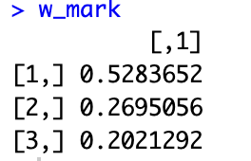
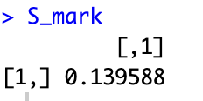

Q3
W_mvp
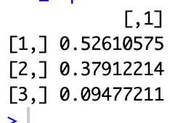
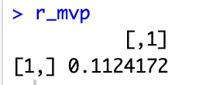
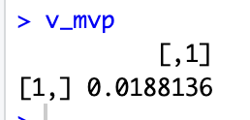
$$σ_{mvp}=\sqrt{0.0188136}≈0,1371627$$
Since r is normal
$$P\left(r_{mvp}<0\right)=N\left(-\frac{μ_{mvp}}{σ_{mvp}}\right)=$$
Q4
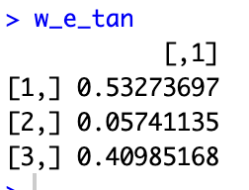
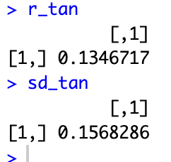
Q5
Under capm
$$w_{tan}=w_{m}$$
Beta regnes
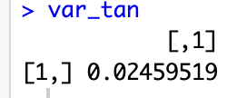
$$β_{p}=\frac{1}{σ_{m}^{2}}w_{p}^{T}Σw_{m}$$
Exercise 2
$$D=\left(\begin{matrix}10 & 30 & 40 \\ 30 & 20 & 0\end{matrix}\right)$$
$$P=\left(\begin{aligned}20 \\ 15\end{aligned}\right)$$
Q1
The comment gives us 2 different set of statepices>0 thus the market is arbitragefree but not complete
Completeness weould require the statepricevektor to be unique

Q2
we are given 2 different sets of stateprices
$$ψ_{1}=\left(\begin{aligned}0.3 \\ 0.3 \\ 0.2\end{aligned}\right)$$
$$ψ_{2}=\left(\begin{aligned}0.1 \\ 0.6 \\ 0.025\end{aligned}\right)$$
$$\left(\begin{matrix}10 & 30 & 40 \\ 30 & 20 & 0\end{matrix}\right)\left(\begin{aligned}0.3 \\ 0.3 \\ 0.2\end{aligned}\right)=\left(\begin{matrix}20 \\ 15\end{matrix}\right)$$
$$\left(\begin{matrix}10 & 30 & 40 \\ 30 & 20 & 0\end{matrix}\right)\left(\begin{aligned}0.1 \\ 0.6 \\ 0.025\end{aligned}\right)=\left(\begin{matrix}20 \\ 15\end{matrix}\right)$$
We also note that a convex combination of these 2 would also give a possible stapricevector(there are more possible)

Q3
$$D^{'}=\left(\begin{matrix}10 & 30 & 40 \\ 30 & 20 & 0 \\ 20 & 30 & 20\end{matrix}\right)$$
$$P^{'}=\left(\begin{aligned}20 \\ 15 \\ 19\end{aligned}\right)$$
$${\left(\begin{matrix}10 & 30 & 40 \\ 30 & 20 & 0 \\ 20 & 30 & 20\end{matrix}\right)}^{-1}\left(\begin{aligned}20 \\ 15 \\ 19\end{aligned}\right)≈\left(\begin{matrix}0,3 \\ 0,3 \\ 0,2\end{matrix}\right)=ψ>0$$
Since D is invertible and $ψ>0$ then the market is arbitragefree and complete
Q4
$$ψ_{0}=0.3+0.3+0.2=0,8$$
$$\frac{1}{1+r_{f}}=0.8$$
$⇕$
$$r_{f}=0,25$$
We make a vector of risk neutral probabilities
$$q=\frac{ψ}{ψ_{0}}=\frac{\left(\begin{matrix}0,3 \\ 0,3 \\ 0,2\end{matrix}\right)}{0.8}=\left(\begin{matrix}0,375 \\ 0,375 \\ 0,25\end{matrix}\right)$$
Q5
We price it with state pricing
We note that it only pays 5 in state 2 and noting in the others
$$P_{c}=\left(\begin{matrix}0 & 5 & 0\end{matrix}\right)\left(\begin{matrix}0,3 \\ 0,3 \\ 0,2\end{matrix}\right)=1,5$$

Opgave 3
Q1
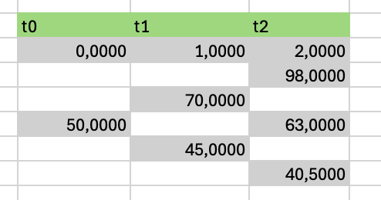
Q2
$$1.05=1+r_{f}∈\left(d,u\right)=\left(0.9, 1.4\right)⇔the model is free of arbitrage and complete$$
$$q=\frac{1+r_{f}-d}{u-d}=\frac{1.05-0.9}{1.4-0.9}≈0,3$$
$$1-q=0.7$$
Q3
$$G_{0,2}=s_{0}·{\left(1+r_{f}\right)}^{2}=50·{1.05}^{2}=55,125$$
Q4
$$G_{1,2}^{u}=s_{0}·u·\left(1+r_{f}\right)=50·1.4·1.05=73,5$$
$$G_{1,2}^{d}=s_{0}·d·\left(1+r_{f}\right)=50·0.9·1.05=47,25$$
The last payment is the difference between the futures price and the actual price
$$G_{2,2}=S_{2}$$

“u”$73,5-55,125=18,375$
“d” $47,25-55,125=-7,875$
“uu” $98-73,5=24,5$
”ud”= $63-73,5=-10,5$
”du” $63-47,25=15,75$
”dd” $40.5-47,25=-6,75$

Q5 we note that the european call only pays in “upup”
$$c_{0}=\frac{1}{{1.05}^{2}}·\left({0.3}^{2}·\left(98-85\right)\right)≈1,0612245$$
$$c-p=S-d·K$$
$$p=c-S+d·K$$
$$P_{0}=1,0612245-50+\frac{1}{{1.05}^{2}}·85≈28,1587302$$
Q6
We see that the value of the call is 0 in “d” since it never pays
$$c_{u}=\frac{1}{1+r_{f}}q·c_{uu}=\frac{1}{1.05}·0.3·13≈3,7142857$$
To replicate we will want to have the payouts at time 2 (if we were to sell) be equal
$$c_{u}=\left(G_{1,2}^{u}-G_{0,2}\right)·Δ+\left(1+r_{f}\right)·B$$
$$c_{d}=\left(G_{1,2}^{d}-G_{0,2}\right)·Δ+\left(1+r_{f}\right)·B$$
$$Skriv ligningen her.$$

$$3,7142857=\left(18,375\right)·Δ+\left(1+0.05\right)·B$$
$$0=\left(-7,875\right)·Δ+\left(1+0.05\right)·B$$
$⇕$ Ligningssystemet løses for Δ,B vha. WordMat's 'Løs Ligninger' funktion,
$$Δ=0,1414966 ∧ B=1,0612245$$
We are long 0.1414 futures and have put 1.0612 in the bank
Being a little cheeky we also know since everyhing is priced under no arbitrage that the price of the replication must be the price of the call and since the price of the futures is 0 then
$$c_{0}=B$$

Exercise 4
Q1
Annuity
$$((100·1.02-x)·1.02-x)1.02-x=0$$
$⇕$ Ligningen løses for x vha. WordMat.
$$x=34,6754673$$
$$B=\left(\begin{matrix}2 & 2 & 102 \\ 52 & 51 & 0 \\ 34,6754673 & 34,6754673 & 34,6754673\end{matrix}\right)$$
Q2
$$P=\left(\begin{aligned}99.800 \\ 100.95 \\ 100.559\end{aligned}\right)$$
$${\left(\begin{matrix}2 & 2 & 102 \\ 52 & 51 & 0 \\ 34,6754673 & 34,6754673 & 34,6754673\end{matrix}\right)}^{-1}\left(\begin{aligned}99.800 \\ 100.95 \\ 100.559\end{aligned}\right)≈\left(\begin{matrix}0,9897827 \\ 0,9702215 \\ 0,9399999\end{matrix}\right)=d>0$$
Since B is invertible and d>0 then the market is complete and arbitragefree
$${\left(\begin{matrix}2 & 2 & 102 \\ 52 & 51 & 0 \\ 34,6754673 & 34,6754673 & 34,6754673\end{matrix}\right)}^{-1}≈\left(\begin{matrix}0,51 & 1 & -1,5001961 \\ -0,52 & -1 & 1,5296117 \\ 0,01 & 0 & -5,768·{10}^{-4}\end{matrix}\right)$$
Q3
Cupon bond:
$$\frac{2}{1+λ}+\frac{2}{{\left(1+λ\right)}^{2}}+\frac{102}{{\left(1+λ\right)}^{3}}=99.800$$
$⇕$
$$λ_{1}=0,0206944$$
$$D_{mac}=\frac{1}{P}\sum_{k=1}^{n}{\frac{t_{k}·x_{k}}{{m·\left(1+\frac{λ}{m}\right)}^{t_{k}}}}$$
$$=\frac{1}{99.800}·\left(\frac{2}{1+0,0206944}+\frac{2·2}{{\left(1+0,0206944\right)}^{2}}+\frac{3·102}{{\left(1+0,0206944\right)}^{3}}\right)≈2,9414972$$

Serial bond:
$$\frac{52}{1+λ}+\frac{51}{{\left(1+λ\right)}^{2}}=100.95$$
$⇕$
$$λ_{2}=0,0135521$$
$$=\frac{\frac{52}{1+0,0135521}+\frac{2·51}{{\left(1+0,0135521\right)}^{2}}}{100.95}≈1,4917809$$

Annuity bond:
$$34,6754673\left(\frac{1}{1+λ}+\frac{1}{{\left(1+λ\right)}^{2}}+\frac{1}{{\left(1+λ\right)}^{3}}\right)=100.559$$
$⇕$.
$$λ_{3}=0,0171435$$
$$\frac{34,6754673\left(\frac{1}{1+0,0171435}+\frac{2}{{\left(1+0,0171435\right)}^{2}}+\frac{3}{{\left(1+0,0171435\right)}^{3}}\right)}{100.559}≈1,9886684$$
Q4
$$f_{1,2}=\frac{d_{1}}{d_{2}}-1=\frac{0,9897827}{0,9702215}-1≈0,0201616$$
$$f_{2,3}=\frac{d_{2}}{d_{3}}-1=\frac{0,9702215}{0,9399999}-1≈0,0321506$$
Q5
The only thing being traded at time 1 is the payment at time 2 we calculate the current price of that payment
$$S_{0}=d_{2}·51=51·0,9702215=49,4812965$$
We use our usual forward formula
$$F_{1}=\frac{S_{0}}{d_{1}}=\frac{49,4812965}{0,9897827}≈49,9920806$$
Q6 we have a formula for this
$$c=\frac{1-d_{2}}{d_{1}+d_{2}}=\frac{1-0,9702215}{0,9702215+0,9897827}≈0,0151931$$

